SEC Form 3
FORM 3 | UNITED STATES SECURITIES AND EXCHANGE
 | COMMISSION
 |  |  | OMB APPROVAL
 | Washington, D.C. 20549
 |  |  | OMB Number: | 3235-
 | INITIAL STATEMENT OF BENEFICIAL OWNERSHIP OF |  |  | 0104
 |  |  | Estimated average burden
 | SECURITIES |  | response: | 0.5
 |  |  | hours per

Filed pursuant to Section 16(a) of the Securities Exchange Act of 1934

or Section 30(h) of the Investment Company Act of 1940
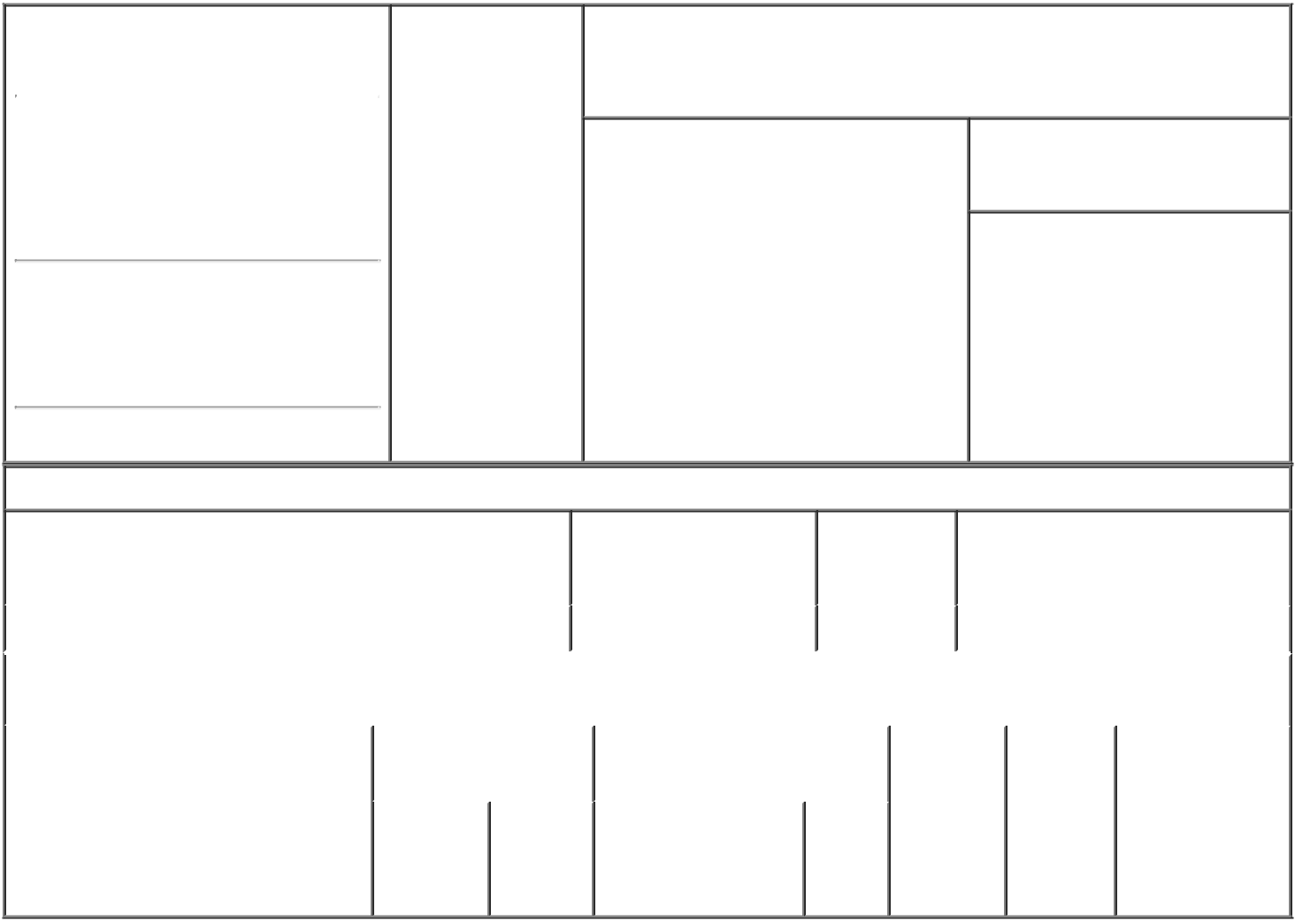

1. Name and Address of Reporting Person* |  |  |  |  | 2. Date of Event
 | JIN ANDY CHING-AN |  |  |  | Requiring Statement
 |  |  |  |  | (Month/Day/Year)
 |  |  |  |  | 07/31/2023
 | (Last) | (First) | (Middle)

3. Issuer Name and Ticker or Trading Symbol

NOCERA, INC. [ NCRA ]

C/O NOCERA, INC.

3F (BLDG B), NO. 185, SEC. 1,

DATONG RD.

(Street)

NEW

TAIPEI F5 221

CITY

- Relationship of Reporting Person(s) to Issuer
(Check all applicable)

X | Director | 10% Owner
X | Officer (give | Other (specify
 | title below) | below)

Chief Executive Officer

- If Amendment, Date of Original Filed (Month/Day/Year)

- Individual or Joint/Group Filing (Check Applicable Line)

- Form filed by One Reporting Person

Form filed by More than One Reporting Person

(City) (State) (Zip)

Table I - Non-Derivative Securities Beneficially Owned

1. Title of Security (Instr. 4) | 2. Amount of Securities | 3. Ownership | 4. Nature of Indirect Beneficial
 | Beneficially Owned (Instr. | Form: Direct | Ownership (Instr. 5)
 | 4) | (D) or Indirect
 |  | (I) (Instr. 5)

 | Common Stock |  |  |  | 240,000⁽¹⁾ | D
 |  |  | Table II - Derivative Securities Beneficially Owned
 |  | (e.g., puts, calls, warrants, options, convertible securities)
 | 1. Title of Derivative Security (Instr. 4) |  | 2. Date Exercisable and |  | 3. Title and Amount of Securities |  |  | 4. | 5. | 6. Nature of
 |  |  | Expiration Date |  | Underlying Derivative Security |  |  | Conversion | Ownership | Indirect Beneficial
 |  |  | (Month/Day/Year) |  | (Instr. 4) |  |  | or Exercise | Form: | Ownership (Instr.
 |  |  |  |  |  |  |  | Price of | Direct (D) | 5)
 |  |  |  |  |  | Amount
 |  |  |  |  |  |  |  | Derivative | or Indirect
 |  |  |  |  |  | or |  | Security | (I) (Instr. 5)
 |  |  | Date | Expiration |  | Number
 |  |  |  |  | Title | of
 |  |  | Exercisable | Date |  | Shares

Explanation of Responses:

- A total of 240,000 shares of restricted common stock were issued pursuant to that certain Employment Agreement dated as of July 31, 2023, by and between Nocera, Inc. and Andy Jin, of which 60,000 shares shall vest on the following dates: (i) October 31, 2023; (ii) January 31, 2024; (iii) April 30, 2024; and (iv) July 31, 2024.

 | /s/ Andy Jin |  | 08/14/2023
 | ** Signature of Reporting |  | Date
 | Person
Reminder: Report on a separate line for each class of securities beneficially owned directly or indirectly.
* If the form is filed by more than one reporting person, see Instruction 5 (b)(v).

- Intentional misstatements or omissions of facts constitute Federal Criminal Violations See 18 U.S.C. 1001 and 15 U.S.C. 78ff(a). Note: File three copies of this Form, one of which must be manually signed. If space is insufficient, see Instruction 6 for procedure.
Persons who respond to the collection of information contained in this form are not required to respond unless the form displays a currently valid OMB Number.

