SEC Form 3
FORM 3 | UNITED STATES SECURITIES AND EXCHANGE
 | COMMISSION
 | COMMISSION |  | OMB APPROVAL
 | Washington, D.C. 20549
 | Washington, D.C. 20549 |  | OMB Number: | 3235-
 |  |  | OMB Number: | 0104
 | INITIAL STATEMENT OF BENEFICIAL OWNERSHIP OF |  |  | 0104
 | INITIAL STATEMENT OF BENEFICIAL OWNERSHIP OF |  | Estimated average burden
 | SECURITIES |  | response: | 0.5
 |  |  | hours per


Filed pursuant to Section 16(a) of the Securities Exchange Act of 1934

or Section 30(h) of the Investment Company Act of 1940
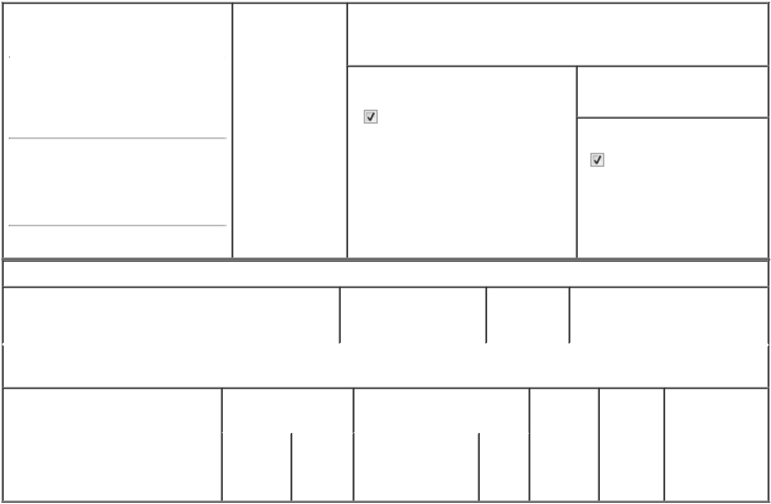

1. Name and Address of Reporting Person* |  |  | 2. Date of Event
 | ZHUANG HUIYING |  | Requiring Statement
 |  |  | (Month/Day/Year)
 |  |  | 12/19/2019

3. Issuer Name and Ticker or Trading Symbol

NOCERA, INC. [ NCRA ]

(Last) (First) (Middle)

C/O NOCERA, INC.

3F (BLDG B), NO. 185, SEC. 1.

(Street)

DATONG

RD., XIZHI F5 221

DIST.

- Relationship of Reporting Person(s) to Issuer
(Check all applicable)

Director 10% Owner

Officer (give Other (specify

title below) below)

- If Amendment, Date of Original Filed (Month/Day/Year)

- Individual or Joint/Group Filing (Check Applicable Line)
Form filed by One Reporting Person

Form filed by More than One Reporting Person

(City) (State) (Zip)

Table I - Non-Derivative Securities Beneficially Owned

 | 1. Title of Security (Instr. 4) | 2. Amount of Securities | 3. Ownership | 4. Nature of Indirect Beneficial
 |  | Beneficially Owned (Instr. | Form: Direct | Ownership (Instr. 5)
 |  | 4) | (D) or Indirect
 |  |  | (I) (Instr. 5)

Table II - Derivative Securities Beneficially Owned

(e.g., puts, calls, warrants, options, convertible securities)

1. Title of Derivative Security (Instr. 4) | 2. Date Exercisable and |  | 3. Title and Amount of Securities |  | 4. | 5. | 6. Nature of
 | Expiration Date |  | Underlying Derivative Security |  | Conversion | Ownership | Indirect Beneficial
 | (Month/Day/Year) |  | (Instr. 4) |  | or Exercise | Form: | Ownership (Instr.
 |  |  |  |  | Price of | Direct (D) | 5)
 |  |  |  | Amount | Price of | Direct (D) | 5)
 |  |  |  | Amount | Derivative | or Indirect
 |  |  |  | or | Security | (I) (Instr. 5)
 |  |  |  | Number
 | Date | Expiration |  | of
 | Exercisable | Date | Title | Shares

Explanation of Responses:

Remarks:

Mr. Zhuang was a director of the Issuer as of December 19, 2019 but did not file his Form 3 at that time. No securities were beneficially owned by Mr. Zhuang at that time up through the date of the filing of this Form 3.

No securities are beneficially owned.

 | /s/ Huiying Zhuang |  | 04/13/2026
 | ** Signature of Reporting |  | Date
 | Person |  | Date
Reminder: Report on a separate line for each class of securities beneficially owned directly or indirectly.
* If the form is filed by more than one reporting person, see Instruction 5 (b)(v).

- Intentional misstatements or omissions of facts constitute Federal Criminal Violations See 18 U.S.C. 1001 and 15 U.S.C. 78ff(a). Note: File three copies of this Form, one of which must be manually signed. If space is insufficient, see Instruction 6 for procedure.

Persons who respond to the collection of information contained in this form are not required to respond unless the form displays a currently valid OMB Number.

